Ten Read-Aloud Commandments
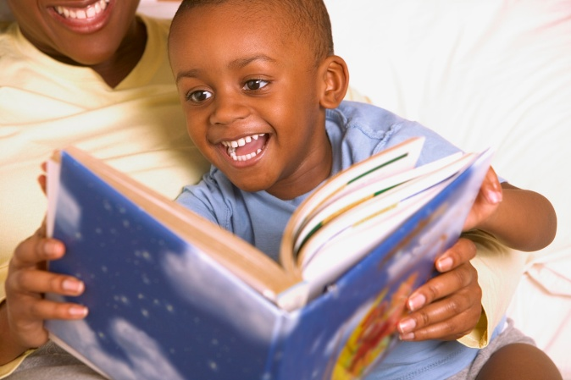

- Spend at least ten wildly happy minutes every single day reading aloud. From birth!
- Read at least three stories a day: it may be the same story three times. Children need to hear a thousand stories before they can begin to learn to read. Or the same story a thousand times!
- Read aloud with animation. Listen to your own voice and don’t be dull, or flat, or boring. Hang loose and be loud, have fun and laugh a lot.
- Read with joy and enjoyment: real enjoyment for yourself and great joy for the listeners
- Read the stories that your child loves, over and over, and over again, and always read in the same ‘tune’ for each book: i.e. with the same intonations and volume and speed, on each page, each time.
- Let children hear lots of language by talking to them constantly about the pictures, or anything else connected to the book; or sing any old song that you can remember; or say nursery rhymes in a bouncy way; or be noisy together doing clapping games
- Look for rhyme, rhythm or repetition in books for young children, and make sure the books are really short.
- Play games with the things that you and the child can see on the page, such as letting kids finish rhymes, and finding the letters that start the child’s name and yours, remembering that it’s never work, it’s always a fabulous game.
- Never ever teach reading, or get tense around books.
- Please read aloud every day because you just adore being with your child, not because it’s the right thing to do.

